

FACULTY OF INFORMATION & COMMUNICATION TECHNOLOGY
PROG102 – PRINCIPLES OF SOFTWARE ENGINEERING
Title : FINAL GROUP PROJECT
Due Date : Week 11
Lecturer/Examiner : Mr. SANTIGIE FODAY KAMARA
Class : BICT1201F
Semester : 2/1
Name of Student/s : GROUP7
NAME | STUDENT.ID | SIGNATURE
GIBRIL AHMAD BARRIE | 905006033
DANIEL MICHAEL FOFANAH | 905006072
ALEX JACOB THOLLIE | 905005573
Academic Honesty Policy Statement
We, hereby attest that contents of this attachment are my own work. Referenced works, articles, art, programs, papers or parts thereof are acknowledged at the end of this paper. This includes data excerpted from CD-ROMs, the Internet, other private networks, and other people’s disk of the computer system
Student’s Signature: Date: 20th /06/2026
LECTURER’S COMMMENTS/GRADE:

Remark
DATE:
TIME:
RECIEVER’S NAME:

DESIGN AND DEVELOPMENT OF A DIGITAL HEALTH INFORMATION SYSTEM FOR IMPROVING HEALTHCARE SERVICE DELIVERY IN SIERRA LEONE
CHAPTER ONE: INTRODUCTION
1.1 Background of the Study ………………………………………….. 1
1.2 Problem Statement ……………………………………………….. 2
1.3 Aim of the Project ………………………………………………. 2
1.4 Objectives of the Project ………………………………………… 3
1.4.1 General Objective ……………………………………………… 3
1.4.2 Specific Objectives ……………………………………………. 3
1.5 Scope of the Project …………………………………………….. 4
1.6 Significance of the Study ………………………………………… 4
1.7 Sustainable Development Goal (SDG) Alignment ……………………….. 5
CHAPTER TWO: SOFTWARE DEVELOPMENT LIFE CYCLE
2.1 Waterfall Model …………………………………………………. 6
2.2 Waterfall Model Phases …………………………………………… 6
2.2.1 Requirements Analysis …………………………………………. 7
2.2.2 System Design …………………………………………………. 7
2.2.3 System Development (Implementation) …………………………….. 8
2.2.4 Testing ……………………………………………………… 8
2.2.5 Deployment …………………………………………………… 9
2.2.6 Maintenance ………………………………………………….. 9
2.3 Justification for Using the Waterfall Model ………………………… 10

CHAPTER THREE: SYSTEM ANALYSIS AND DESIGN
3.1 System Architecture ……………………………………………… 11
3.1.1 Description of the Architecture ………………………………… 11
3.2 Use Case Diagram ………………………………………………… 12
3.2.1 Actors of the System ………………………………………….. 12
3.2.2 Description of the Use Case Diagram …………………………….. 12
3.3 Class Diagram …………………………………………………… 13
3.3.1 Description of the Class Diagram ……………………………….. 13
3.4 Activity Diagram ………………………………………………… 14
3.4.1 Description of the Activity Diagram …………………………….. 14
3.5 Sequence Diagram ………………………………………………… 15
3.5.1 Description of the Sequence Diagram …………………………….. 15
CHAPTER FOUR: USER INTERFACE PROTOTYPE
4.1 System Prototype ………………………………………………… 16
4.2 Splash Screen …………………………………………………… 16
4.3 Login Screen ……………………………………………………. 17
4.4 Registration Screen ……………………………………………… 17
4.5 Patient Dashboard ……………………………………………….. 18
4.6 Doctor Dashboard ………………………………………………… 18
4.7 Appointment Booking Screen ……………………………………….. 19
4.8 Medical Records Screen …………………………………………… 19
4.9 Reports Dashboard ……………………………………………….. 20
4.10 User Management Screen ………………………………………….. 20
4.11 Profile Settings Screen …………………………………………. 21
CHAPTER FIVE: PROJECT MANAGEMENT
5.1 GitHub Repository ……………………………………………….. 22
5.2 Gantt Chart …………………………………………………….. 23
5.2.1 Description of the Gantt Chart …………………………………. 23
5.3 Network Diagram…………………………………………………………………………23
CHAPTER SIX: CONCLUSION
6.1 Conclusion ……………………………………………………… 24
6.2 Future Improvements ……………………………………………… 25
REFERENCES …………………………………………………………… 26

CHAPTER ONE: INTRODUCTION
1.1 Background of the Study
Healthcare institutions in Sierra Leone continue to face significant challenges in managing patient information, scheduling appointments, maintaining medical records, and generating healthcare reports. Many facilities still depend on manual paper-based systems, which often result in misplaced records, delayed service delivery, and inefficient healthcare management.
The advancement of Information and Communication Technology (ICT) provides opportunities to digitize healthcare services through the implementation of a Digital Health Information System. Such systems enable healthcare providers to store, retrieve, and manage patient information electronically, thereby improving efficiency, accuracy, and accessibility of healthcare data.
This project proposes the design and development of a Digital Health Information System that supports patient registration, appointment scheduling, medical record management, and healthcare reporting.
1.2 Problem Statement
Many healthcare facilities experience difficulties in maintaining accurate patient records due to the use of paper-based systems. These challenges include:
Loss of patient records.
Slow retrieval of medical information.
Poor appointment management.
Difficulty tracking patient medical history.
Delays in generating reports.
Inefficient communication between healthcare providers and patients.
These problems negatively affect healthcare service delivery and patient satisfaction.
1.3 Aim of the Project
To design and develop a Digital Health Information System that improves healthcare information management and service delivery.
1.4 Objectives of the Project
1.4.1 General Objective
To develop a Digital Health Information System for healthcare facilities.

1.4.2 Specific Objectives
To digitize patient records.
To improve appointment scheduling.
To provide secure storage of medical information.
To facilitate healthcare reporting.
To improve communication between healthcare providers and patients.
1.5 Scope of the Project
The proposed system will provide:
Patient registration.
Appointment scheduling.
Medical records management.
User authentication.
Healthcare reporting.
Administrative management.
1.6 Significance of the Study
The project will:
Improve healthcare service delivery.
Reduce loss of patient information.
Increase efficiency in record management.
Improve decision-making through accurate reporting.
Support digital transformation in healthcare facilities.
1.7 Sustainable Development Goal (SDG) Alignment
This project supports Sustainable Development Goal 3 (Good Health and Well-Being) by improving healthcare service delivery through digital technology.

CHAPTER TWO: SOFTWARE DEVELOPMENT LIFE CYCLE
2.1 Waterfall Model
The Waterfall Model was selected because it provides a structured and sequential approach to software development. Each phase is completed before the next phase begins.
2.2 Waterfall Model Phases
Requirements Analysis
System Design
Development (Implementation)
Testing
Deployment
Maintenance
Figure 2.1: Waterfall Model
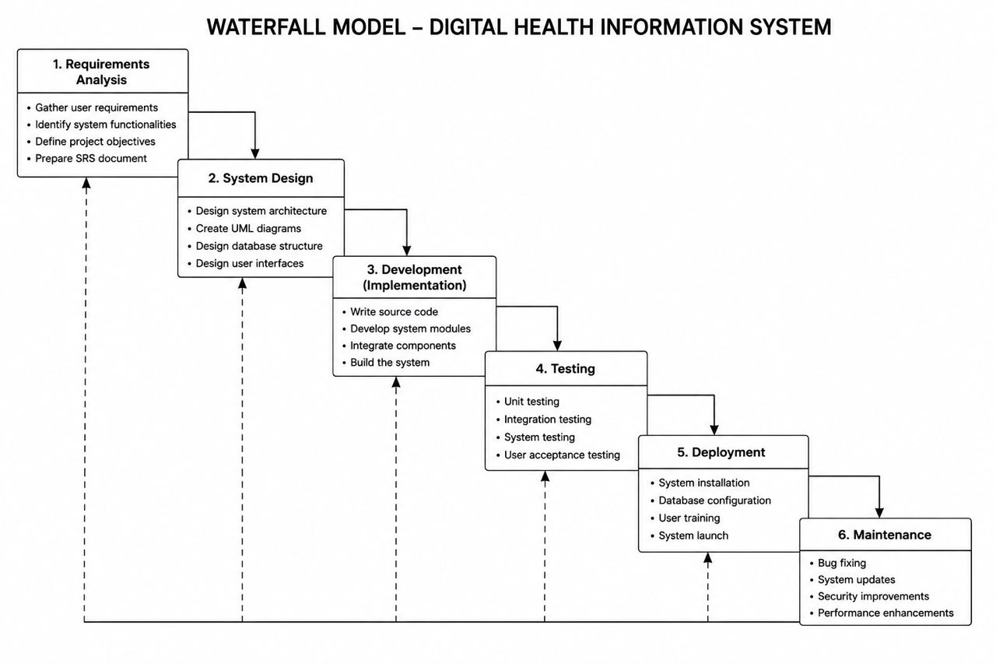
Justification for Using the Waterfall Model
The Waterfall Model is suitable for this project because the requirements are clearly defined and the development process requires proper documentation and systematic progression from one phase to another.
CHAPTER THREE: SYSTEM ANALYSIS AND DESIGN
3.1 System Architecture
The system adopts a three-tier architecture consisting of:
Presentation Layer
Application Layer
Database Layer
Figure 3.1: System Architecture Diagram
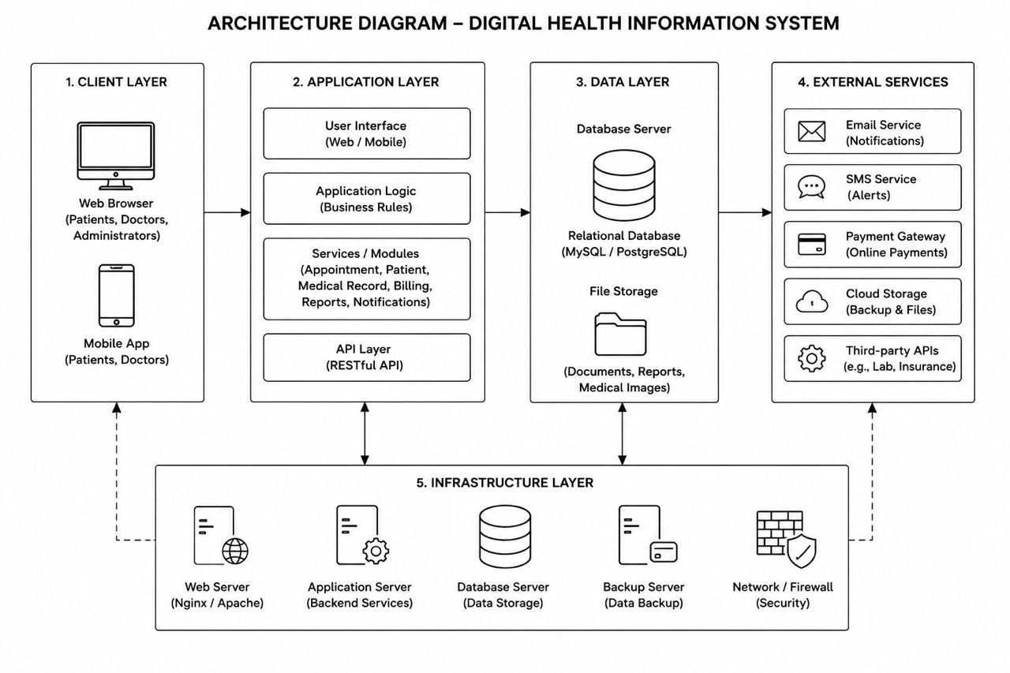
Description
The presentation layer allows users to interact with the system through web and mobile interfaces. The application layer handles business logic and system operations, while the database layer stores patient information, medical records, appointments, and reports.

3.2 Use Case Diagram
The Use Case Diagram illustrates the interactions between system users and the Digital Health Information System.
Actors
Patient
Doctor
Administrator
Figure 3.2: Use Case Diagram
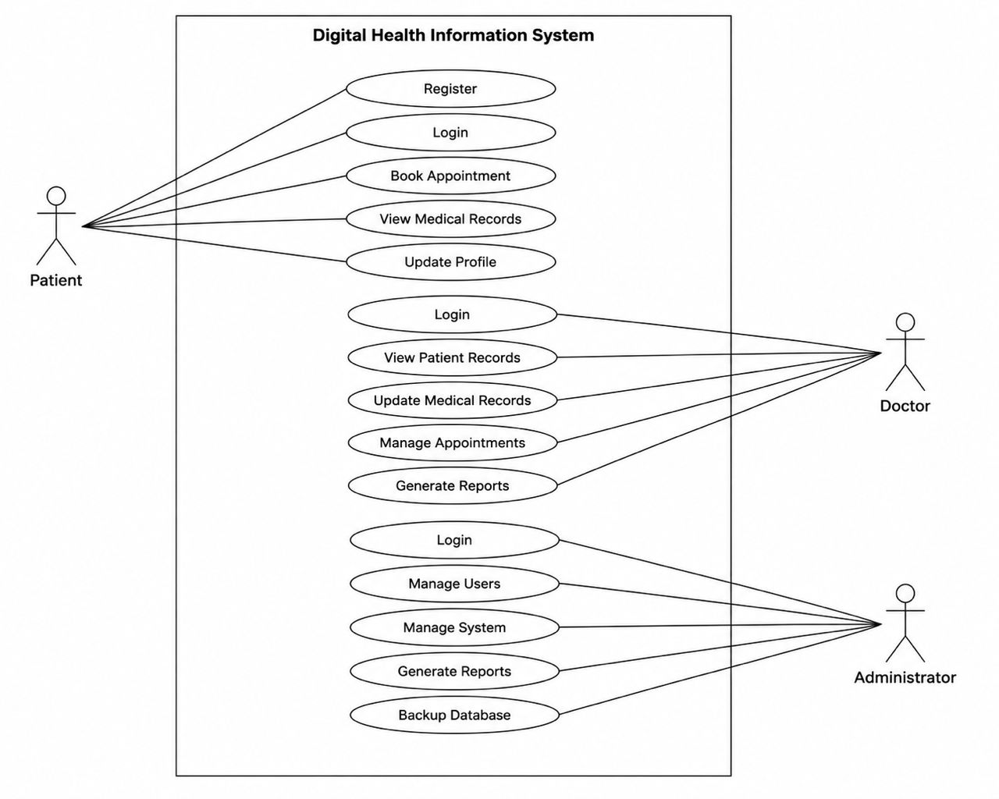
Description
Patients can register, login, book appointments, and view medical records. Doctors can manage patient records and appointments. Administrators manage users, reports, and system configurations.

3.3 Class Diagram
The Class Diagram represents the static structure of the system and relationships among system classes.
Figure 3.3: Class Diagram
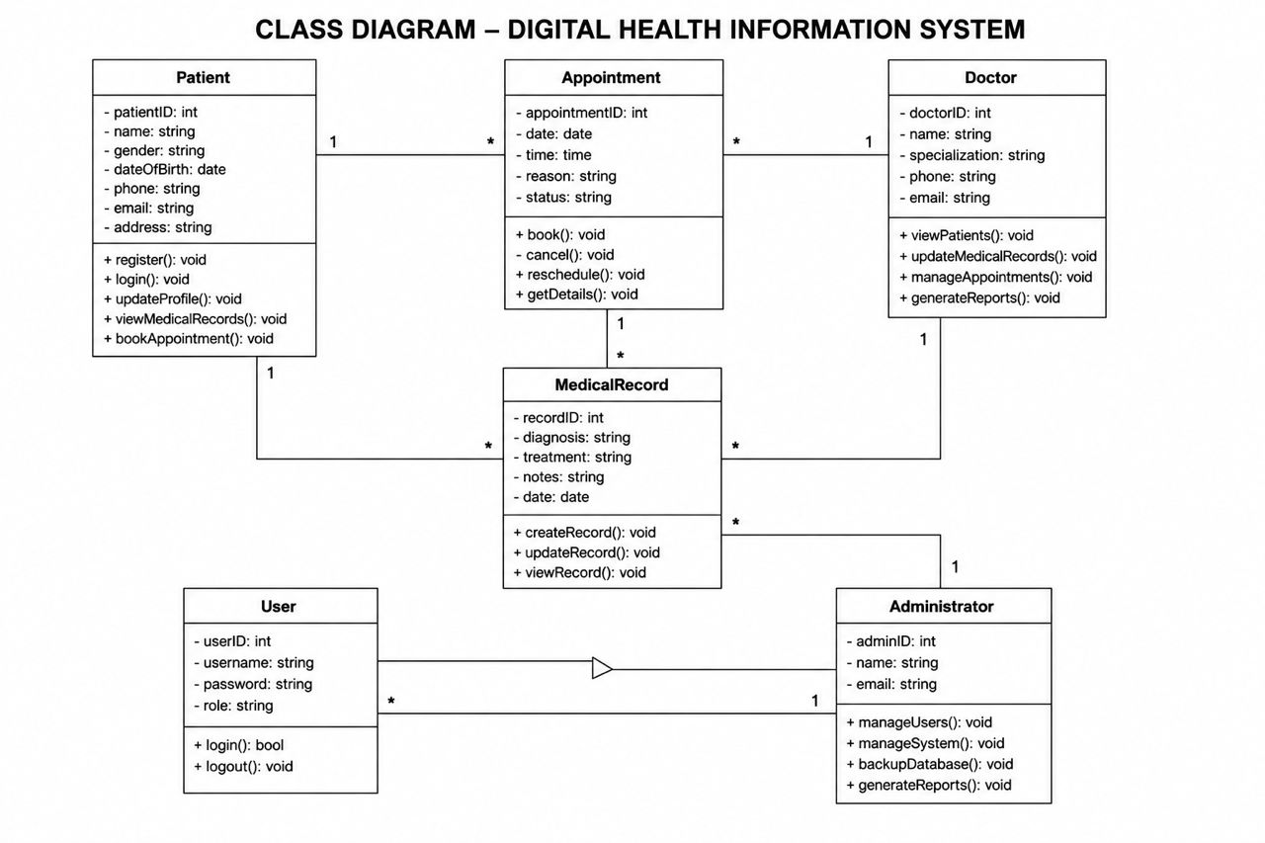
Description
The main classes include:
Patient
Doctor
Appointment
MedicalRecord
User
Administrator
These classes interact to manage patient information and healthcare services.

3.4 Activity Diagram
The Activity Diagram describes the workflow involved in appointment booking.
Figure 3.4: Activity Diagram
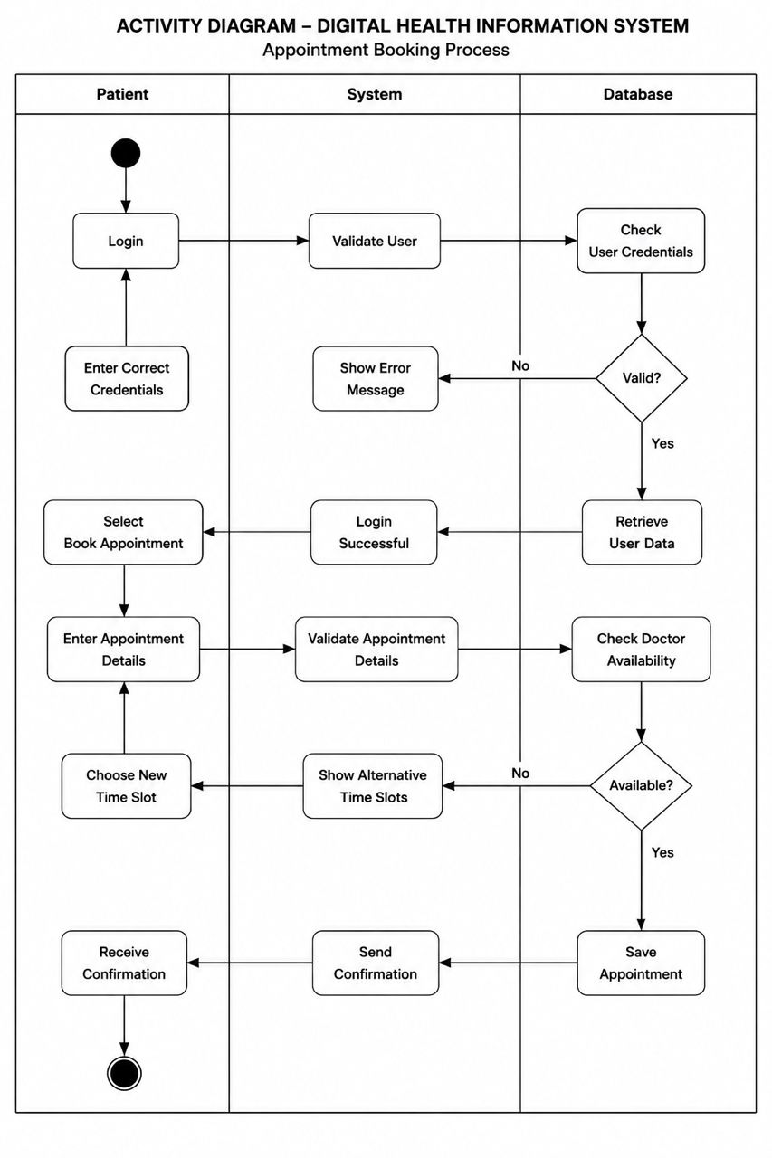
Description
The process begins with patient login, followed by appointment booking, validation, storage, and confirmation.
3.5 Sequence Diagram
The Sequence Diagram illustrates interactions among system components during appointment scheduling.
Figure 3.5: Sequence Diagram
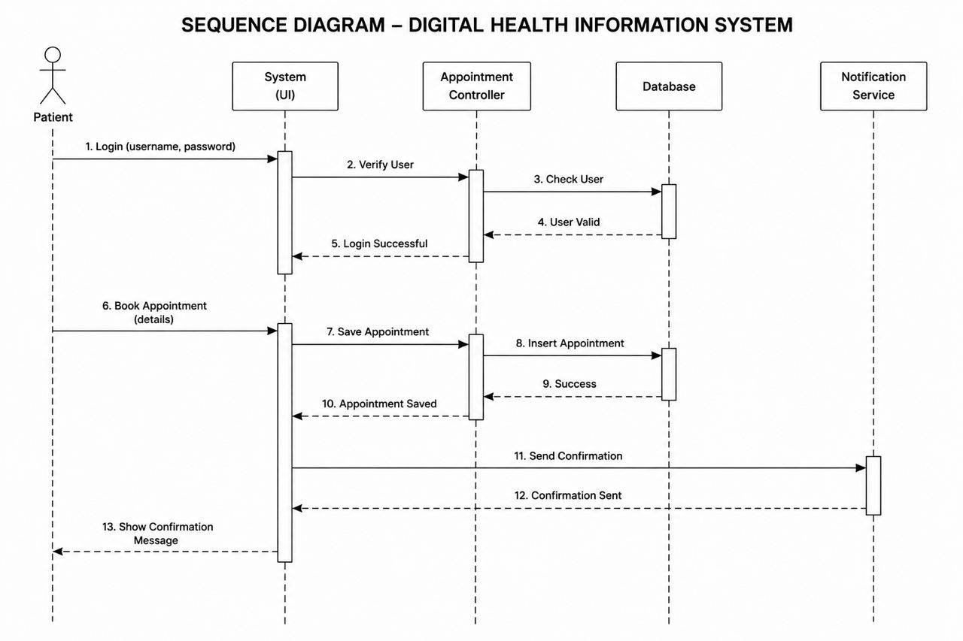
Description
The sequence diagram shows communication between the patient, system interface, appointment controller, database, and notification service during appointment booking.

CHAPTER FOUR: USER INTERFACE PROTOTYPE
4.1 System Prototype
The prototype was designed using Figma to visualize the user interface of the proposed Digital Health Information System.

Figure 4.1: Splash Screen, Login Screen, Registration Screen
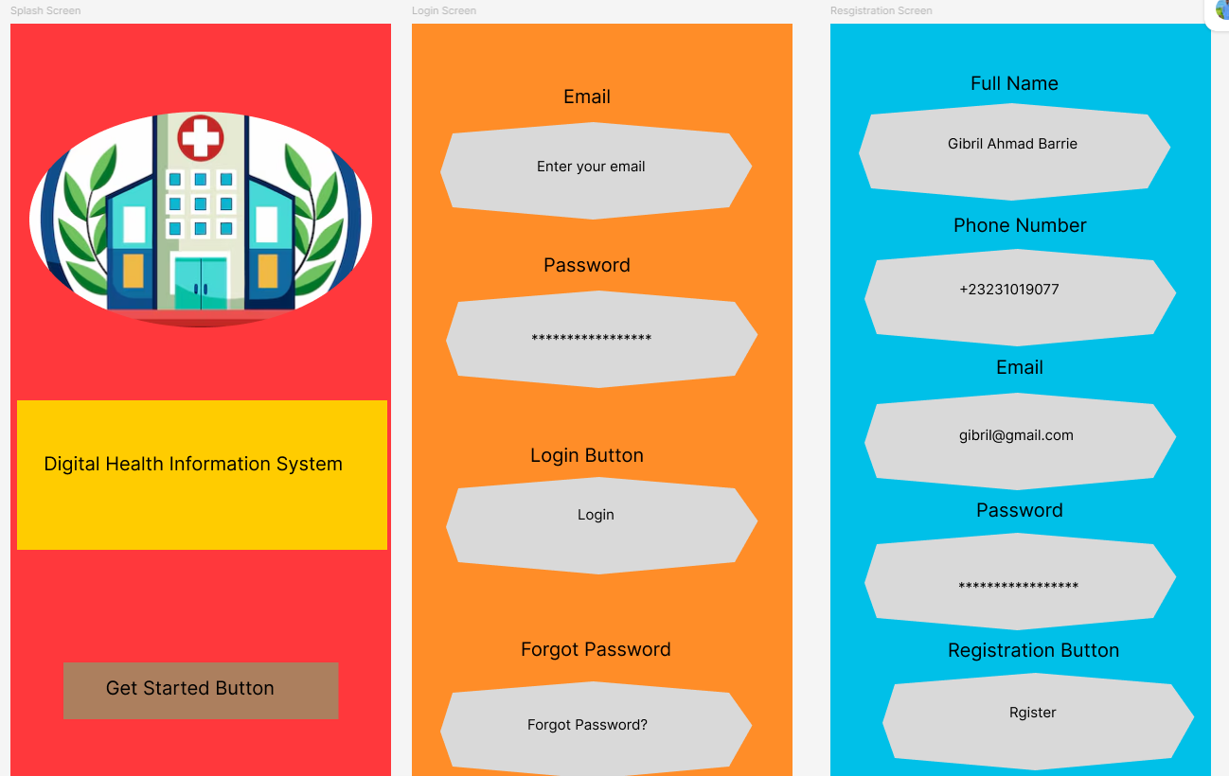

Figure 4.4: Patient Dashboard, Doctor Dashboard, Appointment Booking Screen
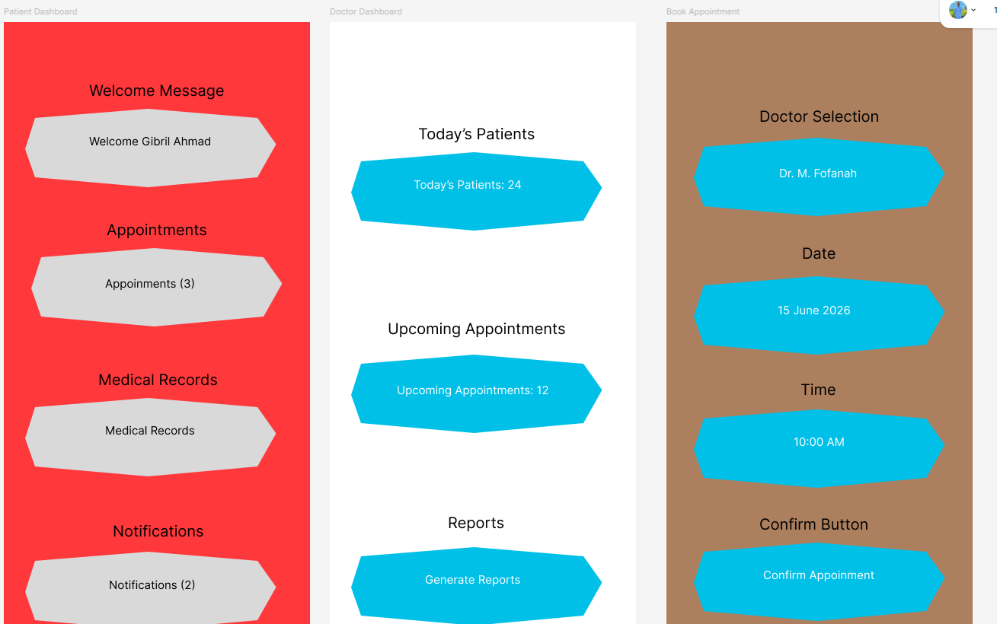

Figure 4.7: Medical Records Screen, Reports Dashboard, User Management Screen, Profile Settings Screen
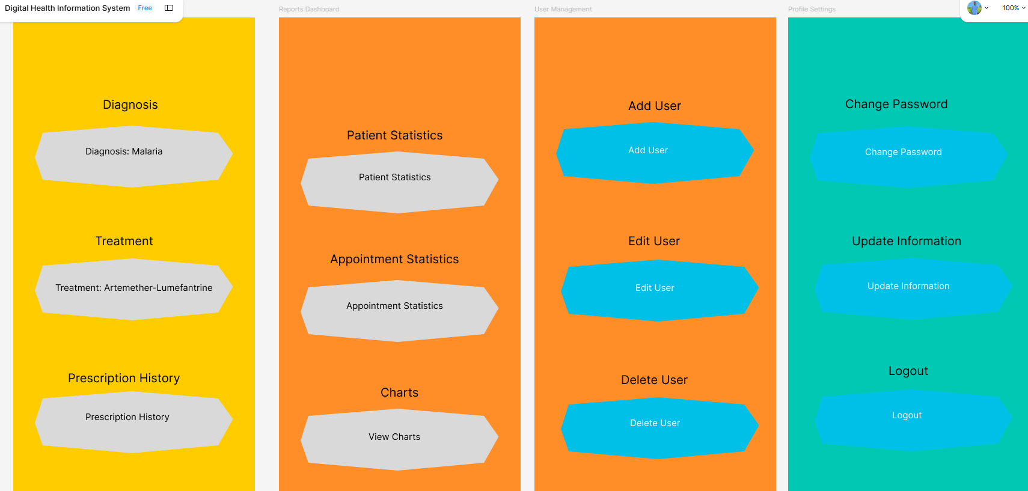

CHAPTER FIVE: PROJECT MANAGEMENT
5.1 GitHub Repository
GitHub was used for version control, project management, documentation storage, and collaboration.
Repository Name:
Digital-Health-Information-System
5.2 Gantt Chart
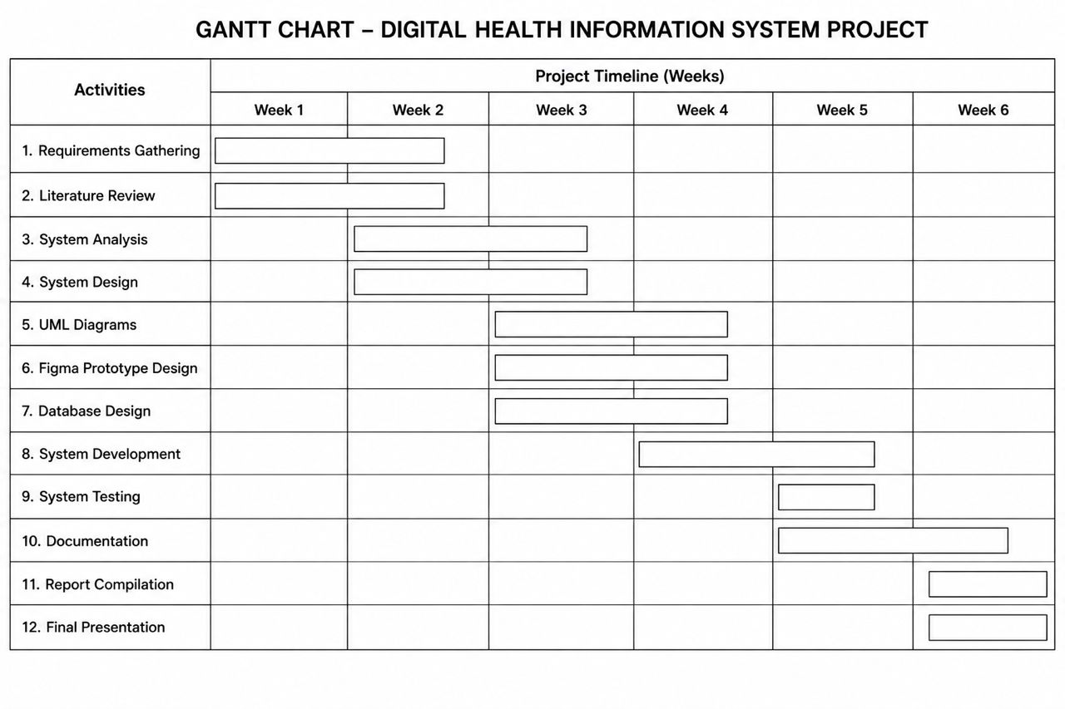
Description
The Gantt Chart presents the project schedule from requirements gathering to deployment and documentation.

5.3 Network Diagram
The Network Diagram illustrates the sequence and dependency of project activities from project initiation to completion.
Figure 5.3: Network Diagram – Digital Health Information System Project
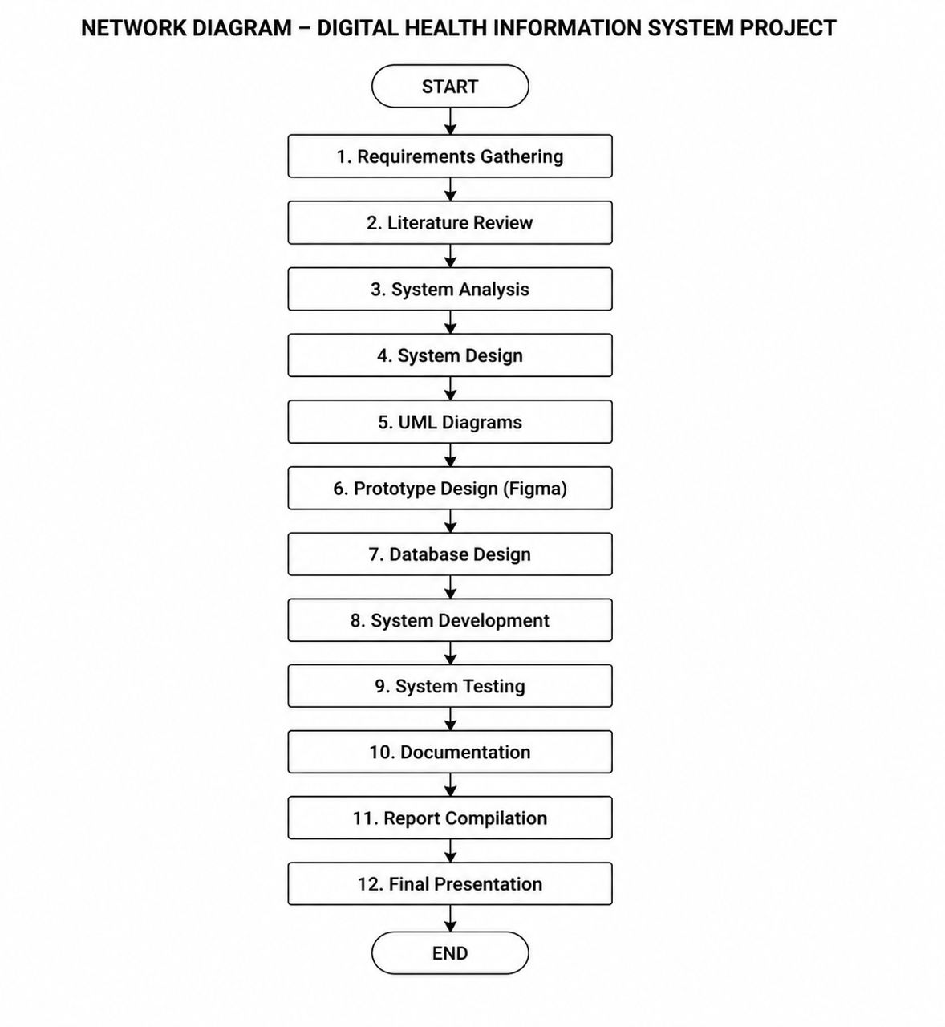

CHAPTER SIX: CONCLUSION
6.1 Conclusion
The Digital Health Information System provides an effective solution for managing healthcare information electronically. The system improves patient record management, appointment scheduling, healthcare reporting, and overall healthcare service delivery.
The project contributes toward the achievement of Sustainable Development Goal 3 by promoting improved healthcare access and digital transformation within healthcare institutions.

6.2 Future Improvements
The proposed Digital Health Information System can be further enhanced through the following improvements:
- Development of a mobile application for Android and iOS devices.
- Integration of SMS and email notification services for appointments and reminders.
- Implementation of online consultation and telemedicine features.
- Integration with national health databases for improved data sharing.
- Enhancement of system security through advanced authentication mechanisms.
- Deployment of cloud-based storage for improved scalability and accessibility.

License
This project is released under the MIT License. Users are permitted to use, copy, modify, merge, publish, distribute, sublicense, and/or sell copies of the software, provided that the original copyright notice and permission notice are included in all copies or substantial portions of the software.
Copyright (c) 2026 Group 7

References
Pressman, R. S. (Software Engineering: A Practitioner’s Approach).
Sommerville, I. (Software Engineering).
World Health Organization (WHO).
United Nations Sustainable Development Goals (SDGs).

